Privacy Impact Assessment (PIA) Template FOR ORGANIZATIONS
Information in italics provides guidance and examples – please replace with your own text.
For more information, please see our guidance document Privacy Impact Assessments for the Private Sector.

Executive Summary

Note the highlights of the initiative, key risks, mitigation strategies, and any other important steps here.

Part 1 general administrative details

- Organization/work unit/author identification

Identify your organization and, if appropriate, the work unit responsible for the initiative. This information will be helpful if your organization plans to update or change the initiative or if there are questions from the public or a regulator.

Organization:
Work unit
(if applicable):
Author:
Email: |  | Phone:
Executive Sponsor
Email: |  | Phone:
Privacy Officer
Email: |  | Phone:
Date of last review: |  | Next review date:
- Initiative description

Provide a general description of the initiative and the context in which it functions. This could include the purpose of the initiative, its benefits, the larger process (if any) that it is part of, how it functions, the parties involved, etc. The more sensitive the personal information involved, for example health care information, the more fulsome this description and the analysis below should be.

- Scope of this PIA
Where applicable, explain exactly what part or phase of the initiative the PIA covers and, where necessary for clarity, what it does not cover.

- Related documentation
Identify PIAs for other parts of the initiative or any PIAs that were previously completed for this initiative, as well as any other relevant supporting documentation. This could include security assessments, the organization’s policies and procedures, and vendor information. It may be helpful to include links to these documents or indicate where the reference material can be found.

Part 2 Operations and Risk Analysis
- Collecting personal information

Note how you will acquire consent from individuals. For example, will the consent be written, verbal, or implicit? If verbal, how will you record the consent? If implicit, how is the collection obvious to a reasonable person? If consent is not required, please indicate which section of PIPA exempts the need for consent. If you are collecting the personal information from another organization, document how you will obtain sufficient information to determine that they collected the personal information with consent and that you are only using the personal information for the purpose(s) they gave the individual.

Note: Consent is not the only requirement for collecting personal information. A reasonable person must also consider the information collected, used, or disclosed to be appropriate in the circumstances.

- Implications of withdrawing consent

Consider the implications of an individual withdrawing their consent for the collection, use, and disclosure of their personal information. Include impacts on the individual’s ability to access or receive services and consider the implications for your organization.

- Notification statement
If your initiative is collecting personal information directly from individuals, you must ensure that they are told the purpose for which the information is being collected and that they agree.
The individual has the right to request the position name or title and the contact information for an officer or employee of the organization who is able to answer questions about the collection.
Note: Notification is not required if collection is with implied consent under s. 8(1) or (2) of PIPA.
Notification statement
Statement: | The notification statement is specific to this initiative. It should include the purpose(s) for the collection of personal information. Your notification statement should be assessed by your privacy officer.  Example: By signing the form below, you consent to our organization collecting your personal information for the purpose of enrolling you in and administering your participation in our initiative.
Initiative contact
Position name or title:
Mailing address:
Email:
Phone number:

- Personal information inventory
List the elements of information or data your organization intends to collect, use, disclose, and retain in relation to the initiative.
Data Element | Sensitivity | Purpose(s) | Role of user | Third party disclosure | Purpose for third party disclosure | Retention period
Surname | Low | Client identification | Client representative | No | N/A | One year from prev. contact
Indv Picture | Medium | Client identification | Client representative | No | N/A | One year from prev. contact
Member # | Low | Marketing | Client representative | Yes | Promotion / advertising | One year from prev. contact
Sales data | Medium | Marketing | Manager / Marketing | Yes | Promotion / advertising | One year from prev. contact
PIPA requires that you only retain personal information for as long as is necessary to fulfill your business and legal obligations.

- Personal information flow table/diagram
Flow table
Provide a flow table for initiatives with simple, single-direction information flows. The table should show how your initiative will collect, use, and disclose personal information. Outline the flows of personal information, including how it will be collected, how it will be used, and any instances in which it will be disclosed, transmitted, or exchanged. The table should also include any authority under PIPA for the collection, use, and disclosure of personal information that is done without consent.
Sample personal information flow table
 | Description/purpose | Type | PIPA Authority
1. | Client completes intake form | Collection | 11(a)
2. | Create patient chart | Use | 14(a)
3. | Review chart and provide treatment | Use | 14(a)
4. | Issue billing | Use | 14(a)
5. | Client provides insurance information | Collection | 11(a)
6. | Disclosure to insurance or credit card company for billing | Disclosure | 17(a)
7. | Receive payment from insurance company | Collection; use | s.12(2); 14(a)
8. | Client pays for their own treatment | Collection; use | s.11(a)
9. | Use information to close transaction | Collection; use | 12(e); 17(a)
Flow diagram
Flow diagrams should be used for more complex transactions. Depending on the complexity of your initiative, you may choose to provide one general flow diagram for the initiative, and more specific diagrams for particular components.
If multiple organizations will collect, use, or disclose personal information, the diagram and narrative should identify how each organization is involved in the initiative.
Flow tables should be used to further explain information within the flow diagram. By using a numbering system on the table, you can identify flows and activities within your diagram and use the table to describe the activity and purpose, type of information flow, and PIPA authority for the activity.
Sample flow diagram
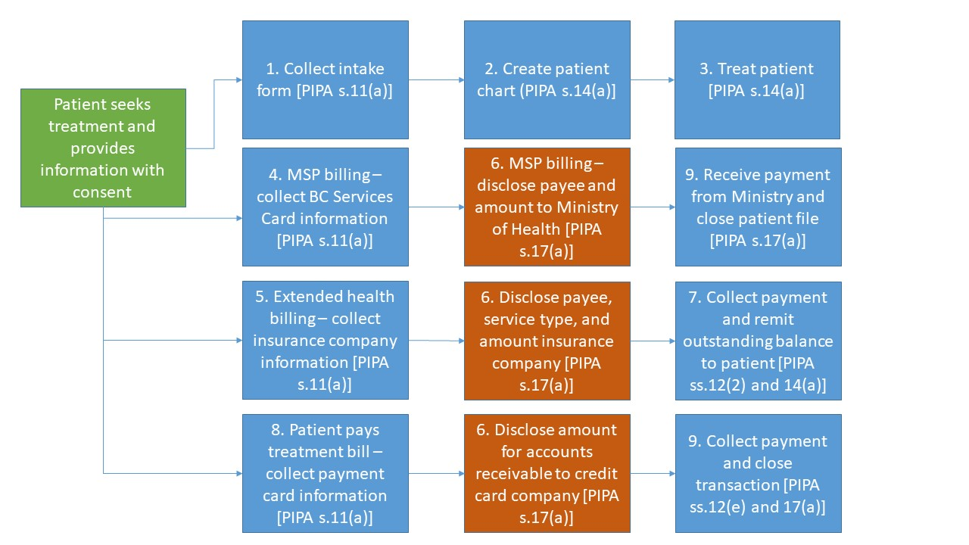

Part 3 Security of Personal Information
- Please describe the physical, technical and administrative security measures related to the initiative.

 |  |  |  | Security Measures
 | Type |  | Type of storage device |  | Security Measure
1. | Physical |  | Paper and USB keys |  | Locked filing cabinet in a secured room
2. | Technical |  | USB keys and hard drives |  | 256-bit encryption
3. | Administrative/ technical |  | Customer management system |  | Role-based access controls
Note: In addition to the table above, you should consider conducting a risk mitigation analysis. See Appendix A for a sample risk mitigation table, which can help you conduct this analysis, identifying and documenting the risks to your organization, their probability and potential impact, and how you intend to reduce those risks.
- Please describe how you monitor compliance
Consider the types of users with access to the personal information in your custody or control and how your organization will check to ensure only authorized individuals access personal information, such as audit trails or physical sign-in and sign-out of files.

Part 4 Access, Accuracy, Correction, & Retention

How can individuals request their own personal information?
Example: the company’s notification statement and privacy policy will direct individuals to your privacy officer.

How can an individual have their personal information updated, corrected, or annotated?
Example: individuals can contact the organization’s privacy officer who will make the update, correction, or annotation. It’s also important to note how requests are made, transferred to the correct areas within your organization, and how the privacy officer can audit the response rate to requests.
If your initiative discloses personal information to third parties, how will you notify them of updates, corrections or annotations? For example: when an update occurs, the privacy officer will provide the program manager with an email outlining the change(s) and obtain confirmation that the program manager sent this to the third parties.

What is your legal or business requirement for the information and how long must you retain information to meet this requirement?

Example: transaction materials from clients may be required for tax purposes for up to seven years. When an organization no longer needs information for legal or business purposes, it must destroy it.

Note: if the personal information is used to make a decision that directly affects an individual, the minimum retention requirement under PIPA is one year.

How will your organization dispose of the personal information after the retention period is completed?

The PIA should identify the procedures for identifying expired records, as well as processes around their transfer to archives or destruction, and where these procedures can be located. You should also indicate the flow for disposal of records within the PIA.

Part 5 Privacy Office(r) Comments
This PIA is based on a review of the material provided to the Privacy Office(r) as of the date below. If any substantive changes are made to the scope of this PIA, the organization should update the PIA and submit it to the Privacy Office(r) for review.

part 6 more information

For more information, please see our guidance document Privacy Impact Assessments for the Private Sector.

PART 7 Signatures
By signing this document, you accept the analysis and risks associated with this initiative. You affirm that you are authorized to sign on behalf of your work unit and/or organization.

Work Unit Manager |  | Signature |  | Date
Contact responsible for systems maintenance and/or security |  | Signature |  | Date
Organization privacy officer Signature Date

Appendix A
Risk Mitigation Table
Identify the privacy risks associated with the initiative and indicate the probability of the risk occurring (low, medium or high) and the severity of the potential impact on individuals.
When scoring the mitigation strategies, consider how the solution will affect the probability or impact should the breach occur. No initiative is completely without risk, so risk will never be zero. See the Scoring Table below to assist in filling out this Risk Mitigation Table.
The final risk score is an indication of the outstanding risk after you have applied the mitigation strategies. It provides your management team with an understanding of the risks the organization will incur if they proceed with the initiative.
Risk Mitigation Table
 | Risks | Probability Score  (P) | Impacts | Impact Score (I) | Mitigation Strategy | Mitigation Score  (M) | Risk Score  (P) + (I) – (M)
1. | Employees could access personal information and use or disclose it for personal purposes | 2 | Embarrassment to the client; loss of employment possibilities | 5 | Terms of employment; contractual terms, training, etc. | 2 | 5
2. | Requests for personal information may not actually be from client (i.e. their email address may be compromised) | 2 | Embarrassment to the client; loss of employment possibilities | 5 | Implementation of identification verification procedures | 3 | 4
3. | Client’s personal information is compromised when transferred to the service provider | 2 | Financial harm from improper billing or identity theft | 5 | Transmission is encrypted and over a secure line | 4 | 3
4. | Inherent risks in sending personal information to a client via email | 3 | Identity theft; inappropriate treatment | 3 | Policy developed to inform clients of risk and ask if they would like the information via a different medium, such as through the mail | 2 | 4

Heat mapping, the process of applying colour to risk levels, will provide management with a strong visual of the risks associated with your initiative. By approving the PIA and initiative, your organization’s management is indicating that those risks are within the organization’s tolerance for risk.

Risk Mitigation Table
 | Probability | (P)  Scores | Impact and Mitigation Levels | (I) and (M)  Scores | (P) + (I) – (M)  Risk Score
 | Very Unlikely | 1 | No impact | 0 | 1
 | Unlikely | 2 | Low impact | 2 | 2 – 3
 | Moderate | 3 | Moderate impact | 3 | 4 – 6
 | Likely | 4 | Moderate-high impact | 4 | 7 – 8
 | Highly Likely | 5 | High impact | 5 | 9 – 10

When considering risks involving personal information, remember the volume and sensitivity of the personal information collected, used, and disclosed in the personal information inventory. A breach involving a large quantity of low sensitivity personal information could be just as damaging to individuals and the organization as a breach involving a small amount of highly sensitive information.

Medium to high impact information incidents may present a real risk of significant harm to the individual. If an information incident occurs, you should consider notifying the individuals involved and the Office of the Information and Privacy Commissioner.

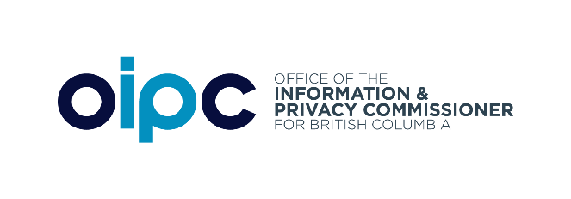

PO Box 9038 Stn. Prov. Govt. Victoria BC V8W 9A4 | 250-387-5629 | Toll free in BC: 1-800-663-7867 info@oipc.bc.ca | oipc.bc.ca | @BCInfoPriv

